Sam Holmes
14307915
DAA Assignment Report

1. Program Description
The program was created to implement the Huffman Compression (HC) algorithm to produce scrambled/compressed alphanumeric text representations of an input string. The way HC works is by creating bit representations of characters that are used in the input text. Optimally, it utilises the notion that symbols that are used most frequently can be represented by a smaller bit-set, reducing the size of the compressed output. It does this through the generation of a Huffman Tree, which prioritise high frequency symbols in it's creation.

2. Program Functionality
Their are three main functions of the program, generation of the frequency tree, encoding of the message and decoding of the message.

2.1 Frequency Generator
The frequency generator is responsible for creating a list of nodes that represent each of the character symbols from the input text. It creates this as a sequential list and stores it for use in the compression and decompression algorithms. It also has methods to display a string representation of this list to the user.
In my design, I decided against allowing the user to manually set a frequency table and decided instead to opt for automatically generating one for all cases, to ensure the optimal compression is utilised. The reason behind this decision is that the nature of this program was to demonstrate the implementation of the algorithm, and the best way to test and prove a test case is to use the same, optimal frequency table throughout.
This functionality wouldn't be hard to add, it would just create a higher chance of potential errors, as the user would have to input the correct frequency table in a specific format to allow it to be parsed and a Huffman Tree created from it. All that would need to change in my code, is allowing the FreqTable.Text box have editing enabled.

Example
Input : “test”

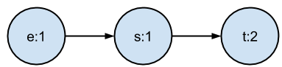

2.2 Huffman Encoder
The Huffman Encoder is responsible for creating a Huffman Tree and creating a look-up dictionary to be used for encoding the message. The way a Huffman Tree is created, is that it is built from the ground up, from the leafs to the root, with the lower frequency nodes taking preference towards the leafs. This is because of how HC creates the binary representations of the symbols, it parses through the tree, and every left branch it takes it equates to a '0' and every right branch a '1'.
What this means is the further from the root node you are, the longer the bit string representing that character will be. This is ideal for compression, as we can set the nodes of lower frequency further from the node as possible, with higher frequency characters being closer, and therefore have a smaller binary representation.

Example
Input : List of frequency nodes as above.

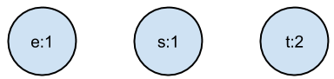

Algorithm : Take the lowest frequency nodes, and pair them together, creating a new node that has the frequency of the sum of those child nodes. Re-add the 'super' node to the list.
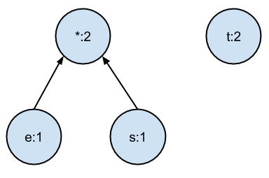

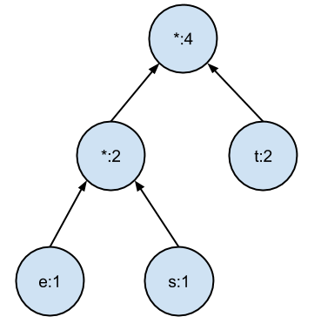
Repeat while list > 1

The tree is now complete, and the binary representations of each character are as follows: t:1, e:00, s:01, meaning our input string 'test' becomes 100011. I then used this binary string to convert it into an alphanumeric char-set that would be sent onwards. I was provided a lookup converter table for 64 different allowable characters, or 2^6 possible characters, meaning every 6 bits will make up 1 character. There is an issue here with if the bit-set does not equal a divisible of six, we will not be able to convert the binary to an alphanumeric representation.
To combat this, I decided to pad the bit string to be exactly % 6 bits long. I did this by appending a '1' at the end of every bit-set, followed by a series of '0's until this condition was met. When the decompression takes place the algorithm removes all the trailing '0's until the '1' is found, which it then removes, leaving the actual bit-set. This means the final sent binary string will be 100011100000, which converts into two decimal numbers '22' & '32'. Using the table provided for this project, 22 corresponds to the character 'V' and 32 to 'f'. Therefore our output compressed message is 'Vf'.

2.3 Huffman Decoder
This Huffman Decoder is responsible for decoding the encrypted alphanumeric message into it's original text. The first thing that it does is convert the text into it's binary representation using the look up table provided in this assignment's specification. It then removes the buffer that was applied to buffer the number of bits to % 6 bits. Following this, it then parses through the Huffman Tree top to bottom, going to the right child for every '1' in the bit-set and to the left for every '0', retrieving the symbol value when it reaches a leaf. The way this works is that the bit-set of a symbol will never be the prefix for another symbols bit-set.

Example
Input : alphanumeric string 'Vf'
Convert to binary : 100011100000
Append buffer : 100011
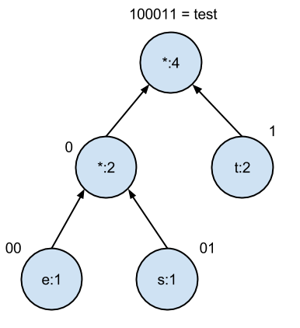

3. Known Defects
The system works perfectly well for compressing and decompressing the text in all situations except for when a user enters a text to be compressed, generates a frequency table and then changes the original text to be compressed, without re-generating a new frequency table representing the changed text. This won't crash the program, however the text will not be compressed correctly and will lead to an incorrect decompression at the other end. This is less of a bug and more poor user interaction. I have left it in for the sake of testing, however it could easily be rectified by simply setting the frequency table to null whenever the original text box has a change occur. This would force a new frequency table to be generated and would solve this issue.

